Contents
Introductory Statement | Page 1
School Information | Page 1
Rationale | Page 1
Belief Statement | Page 1
Aims of the Policy | Page 2
Roles and Responsibilities | Page 2
Identifying Pupils with Additional Needs | Page 6
Information Gathering and Assessment | Page 12
Inventory of Test Materials | Page 12
Prevention and Early Intervention Strategies | Page 13
Meeting the Needs and Allocating Resources | Page 13
Timetabling | Page 15
Tracking, recording and reviewing progress | Page 15
Health and Safety Issues | Page 18
Supervision/Child Protection | Page 18
Ratification and Communication | Page 18
Implementation and Review | Page 18
1
Additional Support Policy Support for All
September 2018

Kildimo National School

Introductory Statement
Our SEN policy was coordinated by the special education team, in consultation with our NEPS psychologist Dr. Richard Egan, in The summer term of 2017/2018. The school’s SEN policy was in need of review in light of the DES new SET Allocation Model 2017 and DES Circular Letter 0013/2017. It was circulated to staff and families in September 2018 and ratified by the BOM on 17th September 2018.

School Setting
Kildimo National School is a co-educational mainstream Catholic Primary School, located in a rural setting 12KM outside Limerick City. The school staff currently consists of Principal, 7 Mainstream Teachers, 2 full time and one shared Special Education Posts, 2 Special Needs Assistants and Ancillary Staff. There are currently 186 children enrolled in the school. Pupils are generally taught in a multi grade setting with 2 classes per room. In allocating classes each year, every effort is made to ensure that Junior Infant and 6th Class pupils are taught in a single class setting. However, this is not always possible, this coming year being a case in point. The average pupil teacher ratio at present is 27:1. Kildimo NS is supported by the National Council for Special Education and NEPS. Our designated NEPS psychologist at present is Dr. Richard Egan.
The school has 7 mainstream classrooms, 2 SEN rooms, a school library, multi-purpose prefabricated hall, kitchen/staff room, secretary’s office and Principal’s office.
The following quote from the school ethos encapsulates the significance of positive relationships within our school context: “The quality of relationships, both the professional relationships between teachers and the ways in which the pupils and teachers interact helps to form a strong sense of social cohesion in our school”.
Rationale
The purpose of this policy is to:
- provide practical guidance to staff, parents and other interested parties about our SEN procedures and practices.
- outline the framework for addressing additional needs in our school.
- comply with legislation (Education Act 1998, Equal Status Act, 2000, EPSEN Act 2004)
- fulfil DES circular 0013/17 -Circular to the Management Authorities of all Mainstream Primary Schools; Special Education Teaching Allocation, and new 2017 Guidelines for Primary Schools: Supporting Pupils with Special Educational Needs in Mainstream Schools).

Belief Statement

Our school is dedicated to the implementation of an effective system for meeting the needs of all our pupils in accordance with our mission statement, the resources provided by the DES and the Board of Management.

Aims of the Policy
This policy aims to outline our procedures and practices in how we:
- identify additional needs that our pupils may have
- allocate resources to effectively meet the needs of children in need of support
- divide the roles and responsibilities among our school community in relation to pupils with additional needs
- track, monitor, review and report on the progress of children with additional needs
- communicate information between SET team, principal, staff, parents/guardians and pupils where appropriate

Roles and Responsibilities
Board of Management:
The BOM oversees the development, implementation and review of school policy on SEN. They also ensure that adequate classroom accommodation, secure storage space and effective teaching resources are provided.

Principal:
The Learning Support Guidelines (2000, P.39) outlined the principal has overall responsibility for SEN procedures and practices in the school. The new allocation model states the principal’s leadership role is central and includes the following;
The school principal should
- Implement and monitor the school’s Additional Needs policy on an on-going basis.
- Assign staff strategically to teaching roles, including special education roles
- Co-ordinate teachers’ work to ensure continuity of provision for all pupils
- Ensure that whole-school procedures are established to facilitate the effective involvement of parents, pupils and external professionals/agencies
- Ensure that effective systems are implemented to identify pupils’ needs and that progress is monitored methodically
- Facilitate the continuing professional development of all teachers in relation to education of pupils with special educational needs, and ensure that all school staff (class teachers, special education teachers and special needs assistants) are clear regarding their roles and responsibilities in this area
- assign responsibility for coordinating additional support to an identified teacher
- communicate with the SENO (Special Education Needs Organiser)
- oversee a whole school assessment and screening programme
- allocate time within the school timetable for the SET team to plan and consult with teachers and parents
- inform staff about external agencies and provide information on continuing professional development in the area of SET
- meet with parents regarding any concerns about their child and update them regarding their progress

SEN Co-ordinator:
SEN co-ordinator (SENCO) should:
- communicate with the principal in relation to SEN matters on an on-going basis
- liaise with external agencies about the provision for pupils with additional needs
- liaise with the NEPS psychologist, the SET team and class teachers to prioritise children for psychological assessments (NEPS)
- co-ordinate regular SET team planning meetings to ensure effective communication and support for children with additional needs
- collaborate with the SET team in creating timetables for additional support
- meet with parents regarding any concerns about their child, advise parents on procedures for availing of special needs services and update them regarding their progress
- co-ordinate the whole-school standardised testing at each class level
- co-ordinate the screening of pupils for additional support, using the results of standardised tests
- select children for external diagnostic assessment, where parental permission has been sought and granted
- maintain lists of pupils who are receiving additional support

Class Teacher:
Class teachers have primary responsibility for the teaching and learning of all pupils in his/her class, including those selected for additional support. They should
- implement teaching programmes which optimise the learning of all pupils and, to the greatest extent possible, prevent the emergence of learning difficulties
- create a positive learning environment within the classroom
- differentiate teaching strategies, approaches and expectations to the range of experiences, abilities, needs and learning styles in their class
- administer and correct standardised tests of achievement in literacy and numeracy, following the school's guidelines
- discuss outcomes of standardised testing with SEN Class Co-ordinators to assist in the selection of children for supplementary teaching
- meet with parents regarding any concerns about their child and update them regarding their progress
- gather information and assess children presenting with needs to inform teaching and learning using the Continuum of Support
- open a Pupil Support File once additional needs have been identified and require classroom support
- develop classroom support plans for children in receipt of Classroom Support
- collaborate with staff to develop Individual Profile and Learning Programmes(IPLP) or Group Profile and Learning Programmes (GPLP) for each pupil in receipt of School Support
- meet with Special Education Teachers, parents/guardians and other staff members to identify priority learning goals for each pupil in receipt of School Support Plus and who require an Individual Education Plan
- collaborate with Special Education Teachers and relevant staff to develop an Individual Education Plan (IEP) for each pupil in receipt of School Support Plus
- meet regularly with Special Education Teachers, relevant staff and parents to review IEP
- where applicable, collaborate with the SET team regarding teaching aims and activities for team teaching
- adjust the class timetable to ensure that children in receipt of supplementary teaching will not be absent for the same subject/activity during each session
- co-ordinate the role and responsibilities of the SNA in relation to the needs of pupils with SEN within the class(es) to which they are assigned

Special Education Teacher (SET)
The SET teacher should:
- familiarise him/herself with a wide range of teaching approaches, methodologies and resources to cater for particular learning styles and to meet a variety of needs
- assist in the implementation of a broad range of whole school strategies aimed at prevention and early intervention
- collaboratively develop Individual Profile and Learning Programmes (IPLP) for each pupil selected for school support teaching with class teachers and other staff
- meet with class Teachers, parents/guardians and other staff members to identify priority learning goals for each pupil in receipt of School Support Plus and who require an Individual Education Plan (IEP)
- collaborate with class teachers and relevant staff to develop an Individual Education Plan for each pupil in receipt of School Support Plus
- regularly meet with class teachers, relevant staff to review IEPs
- meet twice a year with class teachers, relevant staff and parents to review IEP
- update and maintain planning and progress records for each individual or group of pupils in receipt of school support
- provide supplementary teaching for literacy and numeracy on a withdrawal and in-class support basis
- support whole-school procedures for screening
- administer and interpret diagnostic tests and inform class teachers and parents of the outcomes
- meet with parents regarding any concerns about their child and update them regarding their progress
- co-ordinate class groups and offer advice and support to class teachers regarding pupils on their caseload
- discuss the needs and progress of children on their caseload at planning meetings
- provide necessary information to a SEN pupil’s receiving school once a transfer letter has been received
- oversee the tracking system of test results on password-protected Aladdin software to monitor the progress of pupils

Special Needs Assistants:
The duties of the SNA are carried out in accordance with the guidelines for Special Needs Assistants from the Department of Education and Skills and under the direction of the principal/class teachers. The SNA will meet the care needs of the SEN pupils to which they have been assigned. (Circular 10/76).
The SNA should
- support the needs of pupils in effectively accessing the curriculum
- contribute to the quality of care and welfare of the pupils
- support learning and teaching in the classroom
- attend, where possible, training courses/workshops provided by the BOM
- attend IEP meetings and/or meetings with relevant professionals, when necessary
- ensure the safety of the SEN pupils in the schoolyard, and be present for the duration of the yard breaks along with the teachers on duty
- maintain a record of support provided to SEN pupils
- accompany SEN pupils to supplementary lessons when appropriate

Parents/Guardians:
Collaboration and sharing of relevant information between home and school are essential elements of our SEN policy. Parents/Guardians through their unique knowledge of their own children have much to contribute to their child’s learning.
Parent/Guardian should:
- share any information, reports or reports pending from health professionals, and/or concerns regarding their child’s development. Copies of professional reports should be provided to the school at the enrolment stage
- support the work of the school and keep the class teacher informed of the progress and challenges they observe in their child’s learning
- attend meetings arranged by the class teacher or SET team
- support the targets outlined in their child’s support plans and engage in all suggested home-based activities
- inform the post-primary school of their child’s needs, at the transition stage
Pupils:
Pupils who are in receipt of supplementary teaching should, as appropriate:
- be given the opportunity to contribute to the setting of the medium and short-term learning targets
- become familiar with the targets that have been set for them
- develop ‘ownership’ of the skills and strategies that are taught during supplementary teaching and learn to apply these learning strategies and skills to improve their own learning
- contribute to the evaluation of their progress by participating in appropriate assessment activities, including self-assessment

Identifying Pupils with Additional Needs

Continuum of Support
We use the Continuum of Support Framework set out by the Department of Education to identify and support children with additional needs. Like this framework, we recognise that special educational needs occur along a continuum, ranging from mild to severe, and from transient to long-term and that pupils require different levels of support depending on their identified additional needs. By using this framework, it helps us implement a staged approach to ensure that our support and interventions are incremental, moving from class-based interventions to more intensive and individualised support, and are informed by careful monitoring of progress.

The Continuum of Support is a problem-solving model of assessment and intervention that enables us to gather and analyse data, as well as to plan and review the progress of individual pupils.

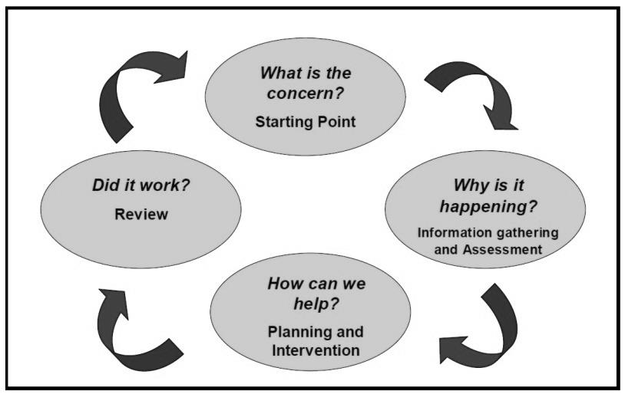
This problem-solving process is illustrated as follows:

Identification of educational needs is central to our policy and the new allocation model. By using the Continuum of Support framework, we can identify pupils’ educational needs, to include academic, social and emotional needs, as well as needs associated with physical, sensory, language and communication difficulties. This, in turn, allows us to identify and respond to needs in a flexible way.
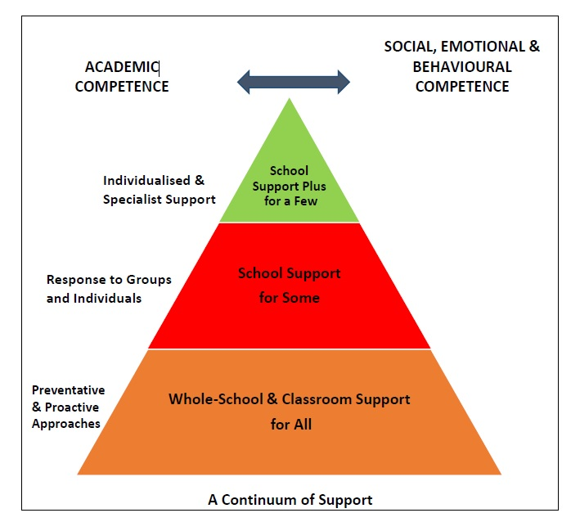
The Continuum of Support suggests the following levels of support:

STAGE 1 CLASSROOM SUPPORT
Classroom Support is the most common, and typically the first response to emerging needs. It is a response for pupils who have distinct or individual educational needs and who require approaches to learning and/or behaviour which are additional to or different from those required by other pupils in their class. Problem-solving at this level typically begins when a parent or teacher has concerns about an individual pupil. The teacher, Class Co-ordinator and parents discuss the nature of the problem and consider strategies which may be effective. Classroom Support incorporates the simple, informal problem-solving approaches commonly used by class teachers to support emerging needs.

STAGE 2 SCHOOL SUPPORT
In some cases, interventions at classroom support level are not enough to fully meet the pupil’s special educational needs. School Support may, therefore, be required. The class teacher needs to involve the Special Education Teacher Team (SET Team) in the problem-solving process at this point and it involves more systematic gathering of information and the development and monitoring of a School Support Plan.

STAGE 3 SCHOOL SUPPORT PLUS
If a pupil’s special educational needs are severe and/or persistent, they are likely to need intensive support. School Support Plus will generally involve personnel outside the school team in the problem solving, assessment and intervention process. However, the information from Classroom and School Support work will provide the starting point for problem-solving at this level. Classroom support and school support will continue to be an important element of his/her individual education plan.

The flow diagrams below outline how we gather information to identify needs and support children with additional needs. A more comprehensive explanation of each stage can be in the Continuum of Support – Guidelines for teachers
https://www.education.ie/en/Schools-Colleges/Services/National-Educational-Psychological-Service-NEPS-/neps_special_needs_guidelines.pdf

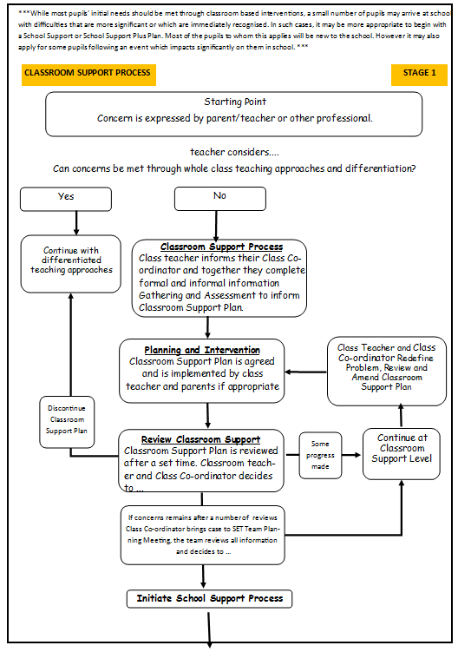
* adapted from NEPS Continuum of Support. For more detailed steps see page 12 - 15 of the continuum of support - Guidelines for teachers
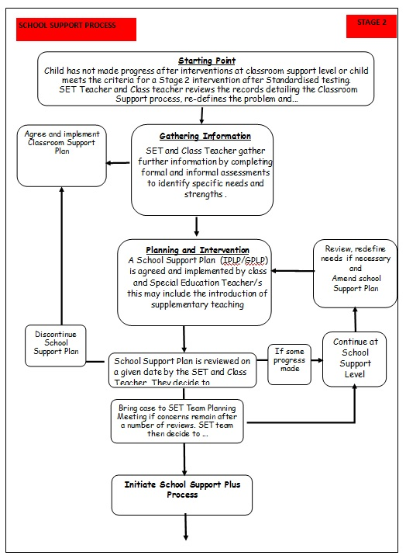
* adapted from NEPS Continuum of Support. For more detailed steps see page 22 - 25 of the continuum of support - Guidelines for teachers
* adapted from NEPS Continuum of Support. For more detailed steps see page 32 - 35 of the continuum of support - Guidelines for teachers
Information Gathering and Assessment
Assessment is part of what a class teacher does on a daily basis for all children. Some methods include self-assessment, questioning, teacher observation, portfolios of work and teacher-designed tasks and tests. The information gathered enables the teacher to plan learning experiences based on the appropriate objectives from the curriculum.

In order to identify pupils who may require supplementary teaching, screening; including standardised testing, is carried out in all classes annually and further diagnostic testing may need to take place. The information gathered from these formal assessments is then used to inform decisions regarding intervention and pupil’s support plans.

Assessment and Screening Tests:
In our school we carry out the following assessment procedures:
- Junior Infants: Observation, Checklists, BIAP (on selected pupils)
- Senior Infants: Observation, Checklists, MIST
- 1st class: Observation, Checklists, Drumcondra Primary Spelling Test, Drumcondra Primary Reading Test, Sigma T, QUEST II
- 2nd class: Observation, Checklists, Drumcondra Primary Spelling Test, Drumcondra Primary Reading Test, Sigma T, CAT 4
- 3rd class: Observation, Checklists, Drumcondra Primary Spelling Test, Drumcondra Primary Reading Test, Sigma T.
- 4th class Observation, Checklists, Drumcondra Primary Spelling Test, Drumcondra Primary Reading Test, Sigma T.
- 5th class: Observation, Checklists, Drumcondra Primary Spelling Test, Drumcondra Primary Reading Test, Sigma T
- 6th class: Observation, Checklists, Drumcondra Primary Spelling Test, Drumcondra Primary Reading Test, Sigma T.

We continually review the assessment and screening tests that we use, so we may deviate from the above list prior to the review date.

Inventory of Test Materials
Screening Tests

- Belfield Infant Assessment Profile (BIAP)
- Middle Infant Screening Test (MIST)
- Micra-T
- Drumcondra Primary Reading Test
- Drumcondra Primary Spelling Test
- Drumcondra Primary Maths Test
- Sigma-T
- Cognitive Abilities Test: Fourth Edition (CAT 4)
- QUEST II Screening Test

Diagnostic and Individualised Tests
In our school the following tests are available for administration:
- Diagnostic Reading Analysis (DRA)  - York Assessment of Reading for Comprehension (YARC)  - Quest II Diagnostic Tests (Literacy & Maths)  - Schonell word reading test | - CHecking Individual Progress Phonics (CHIPPs)  - Assessment of Comprehension and Oral Expression  - Oral and Written Language Scales (OWLS)  - PM Benchmark Reading Assessment Resource  - Psychoeducational Profile: Third Edition (PEP 3)  - Assessment of Basic Language & Learning Skills-Revised Edition & Verbal Behaviour Milestones Assessment & Placement Program (ABLLS-R and VB-MAPP)

Prevention and Early Intervention Strategies
Our strategies for preventing learning difficulties include:
- The development of agreed approaches to the teaching of Literacy and Numeracy to ensure progression and continuity from class to class.
- Provision of additional support in language development and any relevant early literacy and mathematical skills to pupils who need it.
- Ongoing structured observation and assessment of the language, literacy and numeracy skills of pupils in the infant classes to facilitate early identification of possible learning difficulties.
- Close collaboration and consultation between the Infant Teachers and the SET team.
- Promotion of literacy e.g. Print-rich environment, DEAR (Drop Everything and Read), USSR (Uninterrupted, Sustained Silent Reading)
- Phonological awareness activities and games, Sounds Abound programme
- Sight word activities and games, Dolch lists and Jolly Phonics tricky words
- Promotion of Numeracy e.g. Ready Set Go Maths, Numicon, Hands-on approach, Maths for Fun
- Parental involvement in promoting literacy and numeracy e.g. Maths for Fun, Homework Policy Guidelines for Parents.
- Differentiation - adapting the learning environment to support individual needs.
- In-class support from the SET team.
- Team teaching, station teaching, Aistear.
- Withdrawing individuals/groups.
- Literacy Lift Off
- Comprehension Strategy Instruction (Building Bridges of Understanding)
- Reading fluency activities

Meeting the Needs and Allocating Resources
Once pupils’ needs have been identified, Special Education Teachers (SETs) are deployed to address these needs as required. We deploy SETs in a variety of ways to effectively meet our pupils’ needs. We aim to strike a balance between in-class, group and individual support while ensuring that the needs of children with additional needs are met in an inclusive way.

Importantly, the level and type of support reflects the specific targets of individual pupils as set out in their support plans and are informed by careful monitoring and review of progress. In this way, following a period of intervention, some pupils may no longer require additional teaching supports; some may require the same level, while others may require more intensive supports.

In planning the allocation of additional teaching supports, the over-riding principle is that resources are deployed to address the identified needs of pupils. Importantly, those with the highest level of need should have access to the greatest level of support. We consider methodologies best suited to promoting meaningful inclusion such as differentiation, heterogeneous grouping, team-teaching and small group teaching. In addition to literacy and numeracy difficulties, many pupils will have specific needs in such areas as oral language, social interaction, behaviour, emotional development, motor skills and application to learning.

At the end of each term the SET teachers meet class teachers and review children’s needs, the resources in place and progress made using the Continuum of Support problem-solving model of assessment and stage approach flow charts. As a SET team, we review all support and allocate resources for the subsequent term.
We cross-reference the needs of pupils at School Support and School Support Plus levels and consider common needs that can be met by grouping, to ensure effective and efficient teaching and learning approaches.

SELECTION PROCESS FOR ALLOCATING ADDITIONAL TEACHING SUPPORT
Stage 3 School Support Plus | - Children with identified complex needs by an external professional such as a  - Physical Disability  - Hearing Impairment  - Visual Impairment  - Emotional Disturbance  - Moderate General Learning Disability  - Severe/Profound General Learning Disability  - Autistic Spectrum Disorder  - Assessed Syndrome  - Specific Speech and Language Disorder/Impairment | Individual Education Plans | Type of Support  In-Class Support  Team-Teaching  Group Withdrawal  Individual Withdrawal  Personnel  SET teacher  Class Teacher  Outside Agencies
Stage 2 School Support | - Prevention and Early Intervention Programs (Aistear, Literacy Lift Off (J.I.-2nd), Phonological awareness and sight words intervention (J.I.-S.I.), Station teaching, Maths for fun, Friends for life (3rd-6th)  - Children in JI & SI for whom English is an additional language or children for whom English is an additional language newly arrived in Ireland in 1st – 6th  - Children on or under the 12th Percentile in Literacy Standardised Tests  - Children with an identified need assessed by external professionals who are not on or below the 12th percentile in Literacy such as  - Borderline Mild General Learning Disability  - Mild General Learning Disability  - Specific Learning Disability  - Attention Deficit Disorder/ Attention Deficit Hyperactivity Disorder  - Children on or under the 12th Percentile in Numeracy Standardised Tests.  - Children with an identified need as diagnosed by external professionals who are not on or below the 12th percentile in Numeracy  - Borderline Mild General Learning Disability  - Mild General Learning Disability  - Specific Learning Disability  - Attention Deficit Disorder/ Attention Deficit Hyperactivity Disorder  - Children who have not made adequate progress after interventions at Stage 1  - Children in 1st – 6th who have not made adequate progress after EAL interventions | Group or Individual Profile and Learning Programme | Type of Support  In-Class Support  Team-Teaching  Group Withdrawal  Individual Withdrawal  Personnel  SET teacher  Class Teacher

Timetabling
When drawing up timetables it is important to remember that:
- timetables should be continually reviewed
- children should not miss the same subject each time they are withdrawn
- if a pupil is unavailable for their supplementary session due to special circumstances, the Special Education Teacher will endeavour, where practicable, to reschedule the session with the co-operation of another teacher.
- interruptions to classes/classrooms should be kept to a minimum.

Tracking, recording and reviewing progress

Provision for pupils with special educational needs is enhanced through clear identification processes and careful planning of interventions to address academic and/or personal and social development needs. Identification of needs, planning, target-setting and monitoring of outcomes are essential elements of an integrated and collaborative problem-solving process.

Student Support File
We use a Student Support File to plan interventions and to track a pupil’s pathway through the Continuum of Support. This facilitates us in documenting progress and needs over time and assists us in providing an appropriate level of support to pupils, in line with their level of need. Our Student Support File is based on the NEPS template. All support files include:
- Cover sheet with pupil’s details
- A timeline of actions
- Record of support received
- Standardised/ Diagnostic test scores
- Support plans (See below)
- Checklists

A class teacher should open a Student Support File once a child is placed on Stage 1 –Classroom Support on the continuum. This is stored in the pupil’s individual folder in a locked filing cabinet in the classroom.
If, after a number of reviews, the child’s case is moved to School Support, the file is updated, and the SET keeps a copy of the file in a SEN folder in a locked filing cabinet in the Principal’s office. It is the responsibility of the class teacher and the allocated SET to access and update the information in the Student Support File. The same system is in place for children on School Support Plus.

Support Plans
We use three different support plans for the three stages of support on the Continuum of Support.

Stage 1 – Classroom Support
A Support Plan at stage 1 is a Classroom Support Plan. (CSP) This is a simple plan which is drawn up by the Class Teacher in collaboration with the appointed SET which outlines the pupil’s additional educational needs and the actions, including individualised teaching and management approaches, which will be taken to meet the pupil’s needs. The plan may also include home-based actions to be taken by the pupil’s parents to support their child’s development. The Classroom Support Plan should include a review date. This could be at the end of a school term.

Stage 2 – School Support
A Support Plan at stage 2 is a Group or Individual Profile and Learning Programme (GPLP/IPLP). This plan is drawn up by the class teacher and appointed SET. It will set out the nature of the pupil’s learning difficulties, define specific teaching, learning and behavioural targets and set a timescale for review. The plan should, for the most part, be implemented within the normal classroom setting and complimented by focused school based intervention programmes. Depending on the nature of the needs and on the school context, additional teaching might be within a small group or individual support or a combination of both, either in class or on a withdrawal basis. Home-based actions may also be included. After the plan has been drawn up, it should become a working document through the careful monitoring of the pupil’s response to the actions taken.

Stage 3 – School Support Plus
A Support Plan at stage 3 is an Individual Education Plan (IEP). This plan is drawn up by the class teacher and appointed Special Education Teachers, in consultation with the child’s parents/guardians, professionals external to the school and (if appropriate) the child based on the information gathered. It will set out;
- The nature and degree of the pupil’s abilities, skills and talents
- The nature and degree of the pupil’s special educational needs and how those needs affect his/her educational development
- The present level of educational performance of the pupil
- The special educational needs of the pupil
- The special education and related support services to be provided to the pupil including:
- Strategies for supporting the pupil’s progress and inclusion in the classroom setting
- Individual and/or small group interventions/programmes
- Specific methodologies/programmes to be implemented
- Specific equipment/materials and/or IT supports, if required to support learning and access to the curriculum
- Support required from a Special Needs Assistant (SNA), if appropriate
- The goals which the pupil is to achieve over a period not exceeding 12 months
- The pupil’s priority learning needs, long and short term targets to be achieved and the monitoring and review arrangements to be put in place

IEP meetings are coordinated by an appointed IEP coordinator. This is usually one of the child’s Special Education Teachers. Parents will be invited to an initial IEP meeting in September and a review meeting in January/February.

IEP CYCLE
SEN Records
Individual SEN Files
All pupils’ SEN files are stored in a locked filing cabinet in the SET’s room and a copy is kept in the principal’s filing cabinet in a SEN folder for the current school year. It is the responsibility of SETs to update and manage the files of the children on school support and school support plus that they support. It is the responsibility of the class teachers in consultation with appointed SET to update and manage the SEN files of children on classroom support. The following should be stored
- Student Support File
- Psychological Report
- Copy of referrals made to outside agencies
- Copy of reports from outside agencies
- Record of SEN meetings with parents, outside agencies and inter-school meetings
- Record of SEN correspondence between parents, outside agencies and school staff

Whole Class SEN Files
Whole class SEN records are stored in a locked filing cabinet in the principal’s office. It is the responsibility of the SENCO to manage and update these. The following should be stored in these whole class SEN folders:
- End of Term Needs Analysis record sheets
- Whole class test results (SIGMA – T, MICRA – T, Drumcondra Primary Reading Test, Drumcondra Primary Spelling Test, CAT-4)
- Overview of SEN provision in current school year including a list of children in receipt of additional support and timeframe for early intervention and team teaching interventions.

Communication between SET Team/Principal/Class Teachers
SET timetables have been organised so that 1:00-2:45 each Friday is our designated co-ordination time. This allows all staff the opportunity to attend pupils support planning meetings, care team meetings, Team Teaching Planning Meetings and SEN consultation/planning/review meetings, when necessary. This flexibility ensures adequate cover for class teachers and facilitates regular SET team planning meetings with the principal.

Health and Safety Issues
Every staff member and pupil are entitled to a safe, secure environment and to be treated with due respect. All appropriate measures are taken to ensure the safety of each pupil with SEN. When a place is offered to a child with SEN, every effort will be made to ensure that the supports to which the child is entitled are in place as soon as possible. Staff members will be informed of any potential risks and, where necessary, individual plans will be drawn up and implemented.

Supervision/Child Protection
- Where pupils receive support on a one-to-one basis, the SET teacher is responsible for ensuring that both teacher and pupil are visible through the glass panel in the door.
- Where the there is no glass panel, the door of the room should remain open.
- Where pupils are withdrawn for support, the SET teacher should collect and return children to their classrooms.
- Where a child has access to an SNA, the child may be withdrawn from the class where a plan is in place with the class teacher.

Ratification and Communication
This revised policy was ratified by the Board of Management on 17th September 2018.

Implementation and Review
This policy will be implemented from September 2018. It will be reviewed in June 2019 by the Special Education Team and all staff at Kildimo N.S., pending a proposed review of the New SEN Allocation Model by the Department of Education and Skills in 2019.

Signature: _____________________________________
(Rev. Fr. John Donworth Chairperson BOM)

Date: ___________________________

